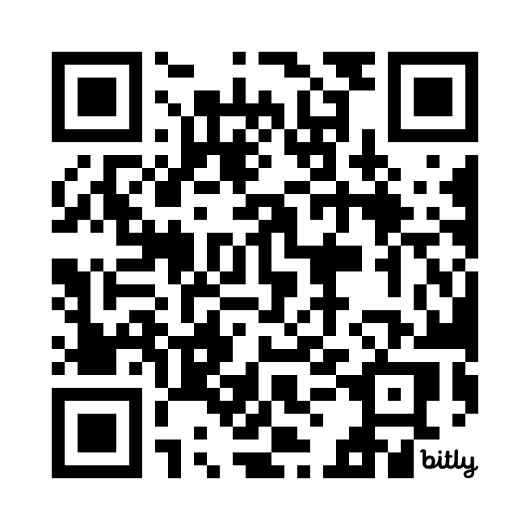OGBONNA GODSWILL

Phone: 09068604535

Email: [godswillogbonna445@gmail.com](mailto:godswillogbonna445@gmail.com)

LinkedIn: <https://www.linkedin.com/in/godswill-ogbonna-9094bb317/>

Website: https://bit.ly/Godslovedev

Address: Oyimo Laguru, Ubakala, Umuahia South LGA, Abia State, Nigeria.

**Professional Summary**

Dedicated Frontend Web Developer with proficiency in HTML5, CSS, and JavaScript. Demonstrated commitment and excellence throughout academic and professional endeavors. Experienced in lecturing physics courses, organizing computer and web design classes, and managing an electronics shop. Skilled in video editing, graphic design, electrical and electronics engineering, and pencil art. Passionate about music and proficient in keyboard playing. Capable of creating simple websites for personal use, small businesses, churches and small organizations. Proficient in creating QR codes and using Bitly link shortener. Experienced in projection for business and leadership seminars.

**Skills**

* **Technical Skills:** HTML5, CSS, JavaScript, Video Editing, Graphic Design, Computer Skills, Google Forms, Google Drive, QR Code Creation, Bitly Link Shortener.
* **Soft Skills:** Strong communication, commitment, teamwork
* **Artistic Skills:** Pencil Art
* **Musical Skills:** Keyboard playing
* **Engineering Skills:** Electrical and Electronics Engineering, Maintenance
* **Presentation Skills:** Projection for business and leadership seminars

**Education**

Bachelor of Science (B.Sc.) in Physics

Michael Okpara University, Abia State, Nigeria — [2023]

- Awarded the Most Committed Student

West African Senior School Certificate Examination (WASSCE)

Evangel High School Old Umuahia, Abia State, Nigeria — [2016]

First School Leaving Certificate

Ubakala Central School, Umuahia Abia State, Nigeria — [2010]

**Professional Experience**

**Frontend Web Developer**

*Freelance* — 2024 - present

* Created and maintained websites for personal, business and organizational use.
* Utilized HTML, CSS and Javascript to deliver user-friendly and responsive web designs

**Lecturer (NYSC)**

*College of Education Waka BIU, Borno State,* Nigeria — January/2024 to October/2024­­

* Lecture Physics, contributing to the academic development of students.
* Organized computer classes and web design classes, enhancing students' technical skills.
* Served as the PRO for NYSC CDS group (SDGs) Sustainable Development Goals, promoting community development initiatives.

**Electronics Shop Manager**

*Divine Favour Electronics, Umuahia Abia State*  — 2013 to 2023

* Managed day-to-day operations of the shop, including inventory management, customer service, and sales.
* Implemented effective sales strategies, resulting in increased revenue.

**Projects**

Electric Bulb with Sensor and Storage

* **Description:** Built an electric bulb that can store current and has a sensor to detect day and night, automatically turning on during the night and off during the day.
* **Role:** Designer and developer.
* **Technologies Used:** Electrical components and sensor technology.

Developed Personal and Small Scale Business websites

* **Description:** Built and hosted websites for both personal and small scale business.
* **Role:** Designer and developer.
* **Technologies Used:** HTML5, CSS, JavaScript.

**Awards & Honors**

- Most Committed Student, Michael Okpara University, Physics Department — 2023

**Certifications**

- SDGs Certificate, NYSC — November/2023

**Volunteer Experience**

PRO for CDS (SDGs) Sustainable Development Goals

NYSC BIU LGA, Borno State, Nigeria — January/2024] to [September/2024

* Promoted community development initiatives and organized events related to sustainable development.

**References**

Available upon request.